**H1Pay**

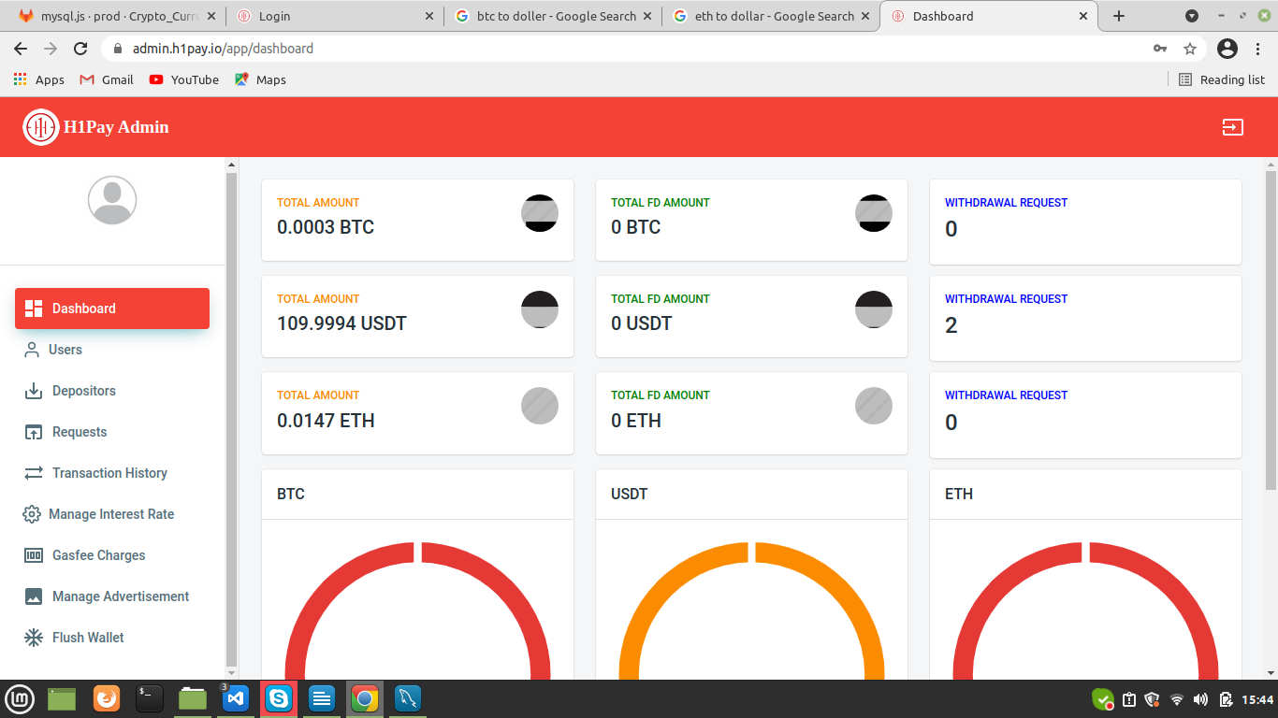

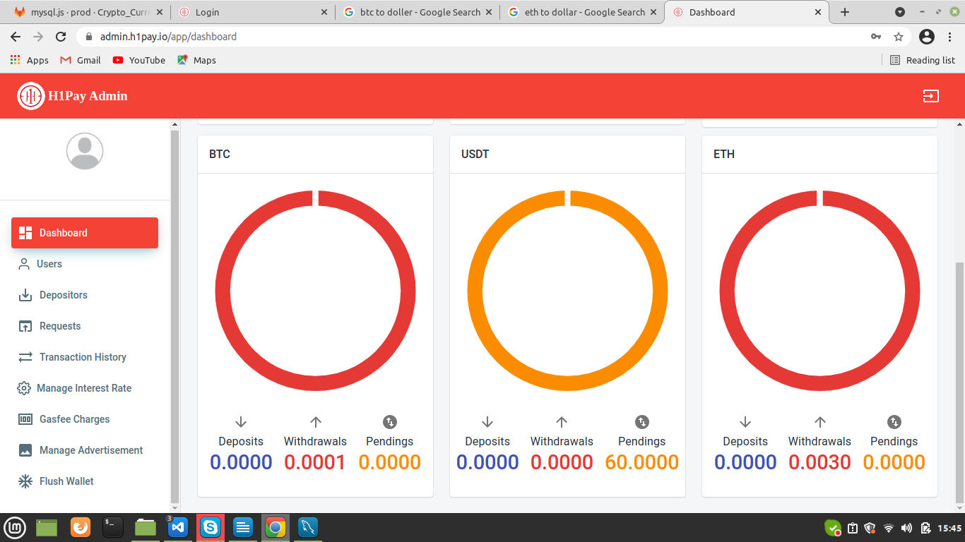

By clicking on the Dashboard, it displays the total amount of BTC, USDT and ETH of admin. Also fixed deposit list of users and deposits, withdrawals and pending transactions list.

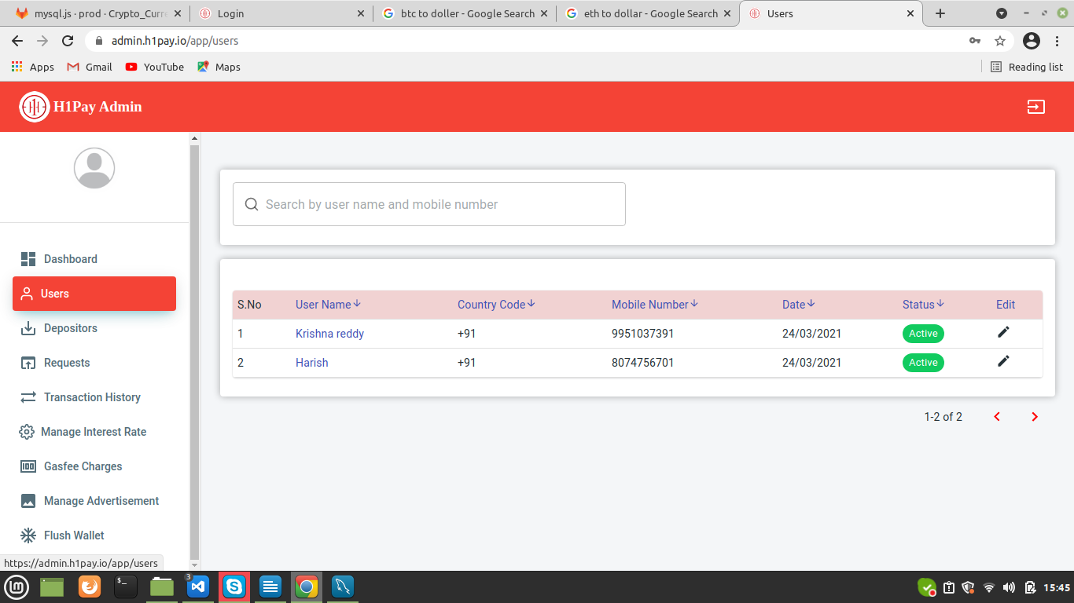

By clicking on the Users tab, it displays the number of users registered in our application along with the current status of the user.

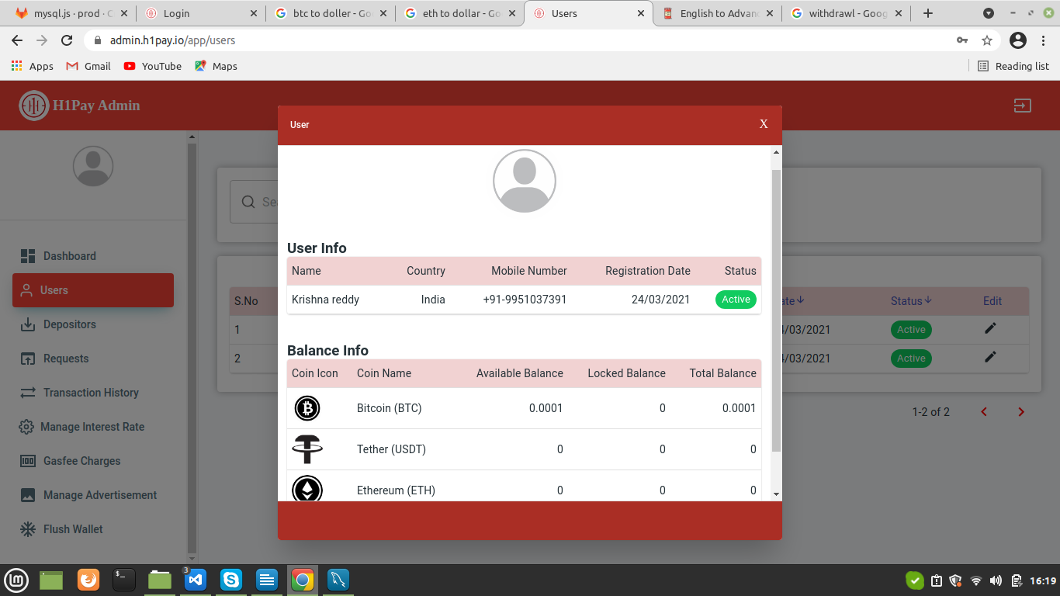

By clicking on User name, it displays the details and balances of the user.

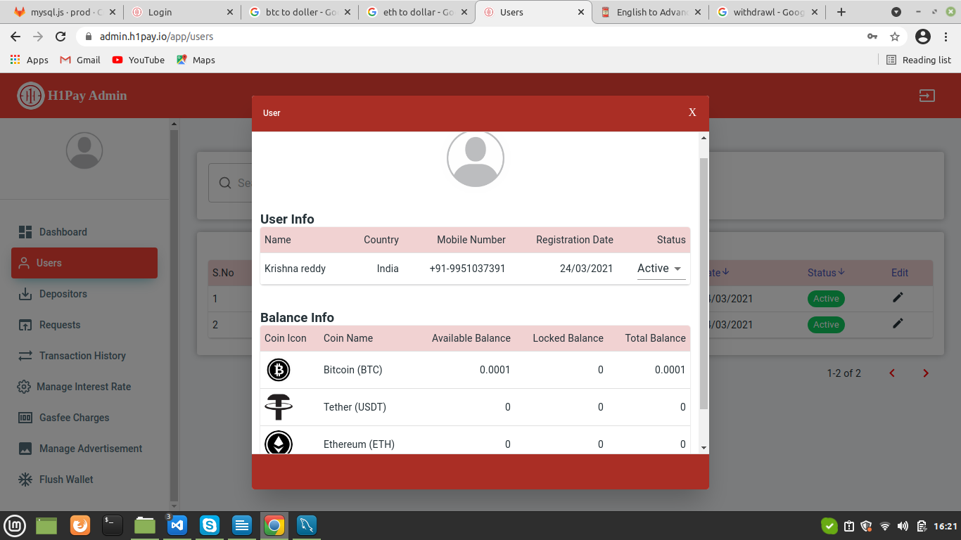

By clicking on Edit button, we can make active or inactive of user account.

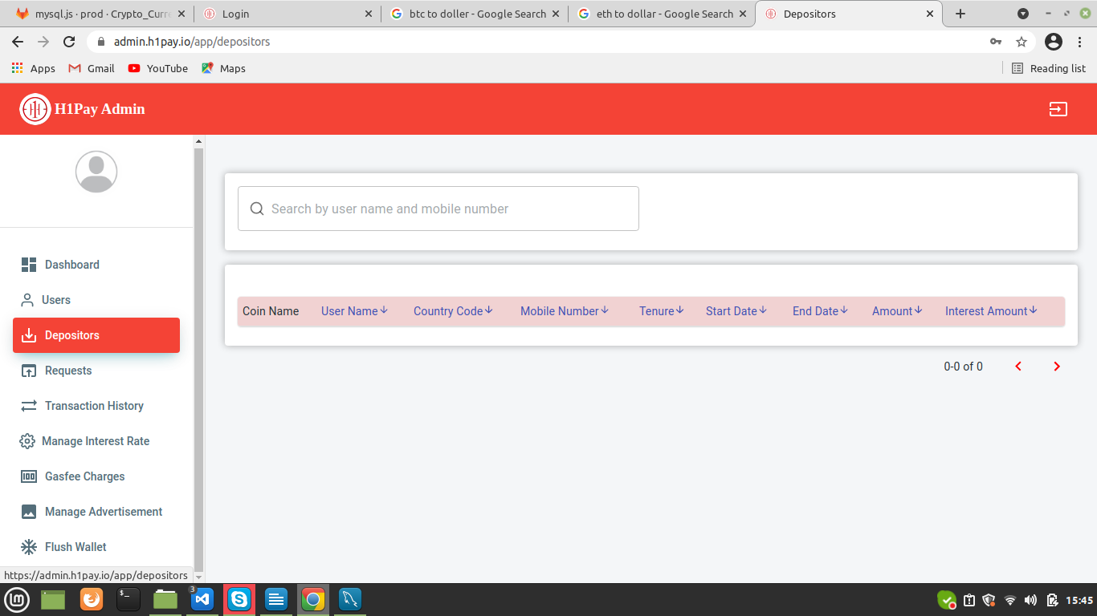

By clicking on Depositors, it displays the number of users who deposited their USDT funds in it.

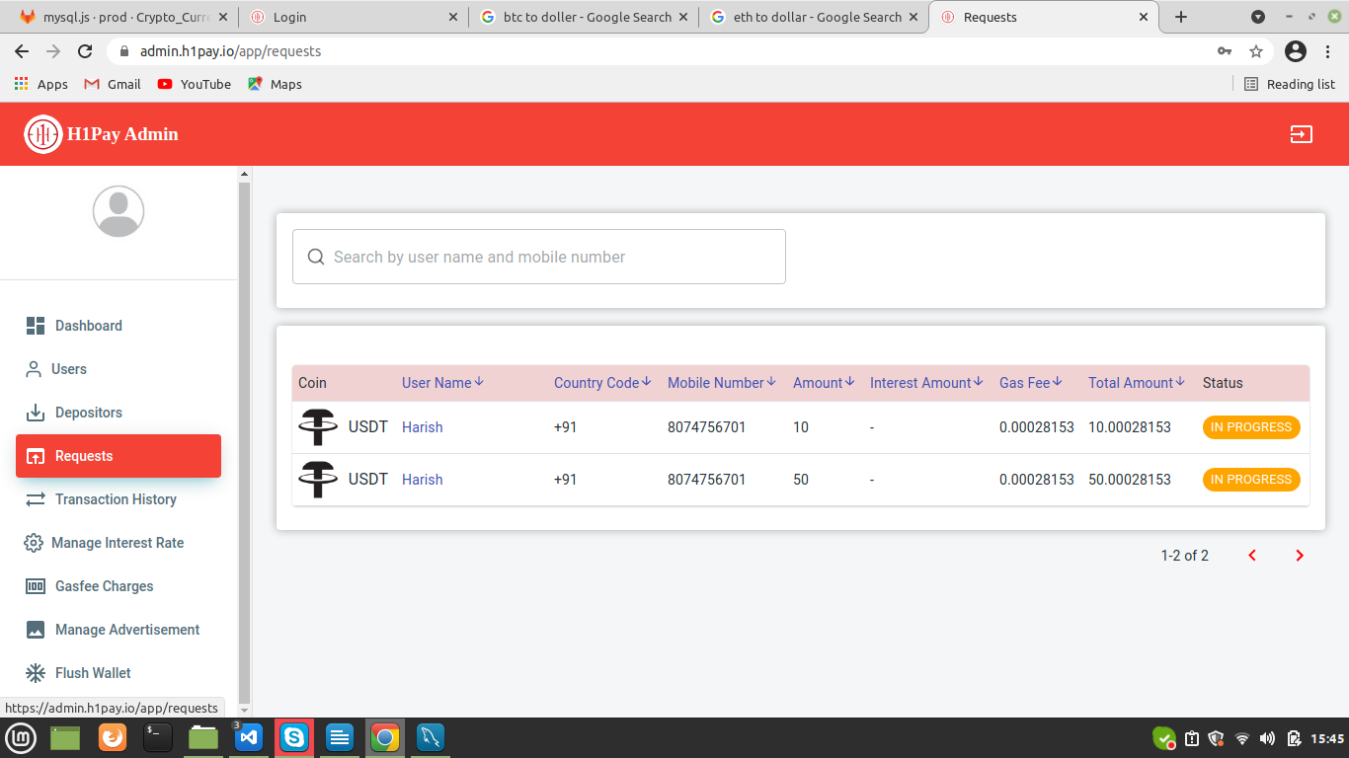

By clicking on Requests, it displays the withdrawal request from user. It’s an admin responsibility to accept or reject or hold the transaction.

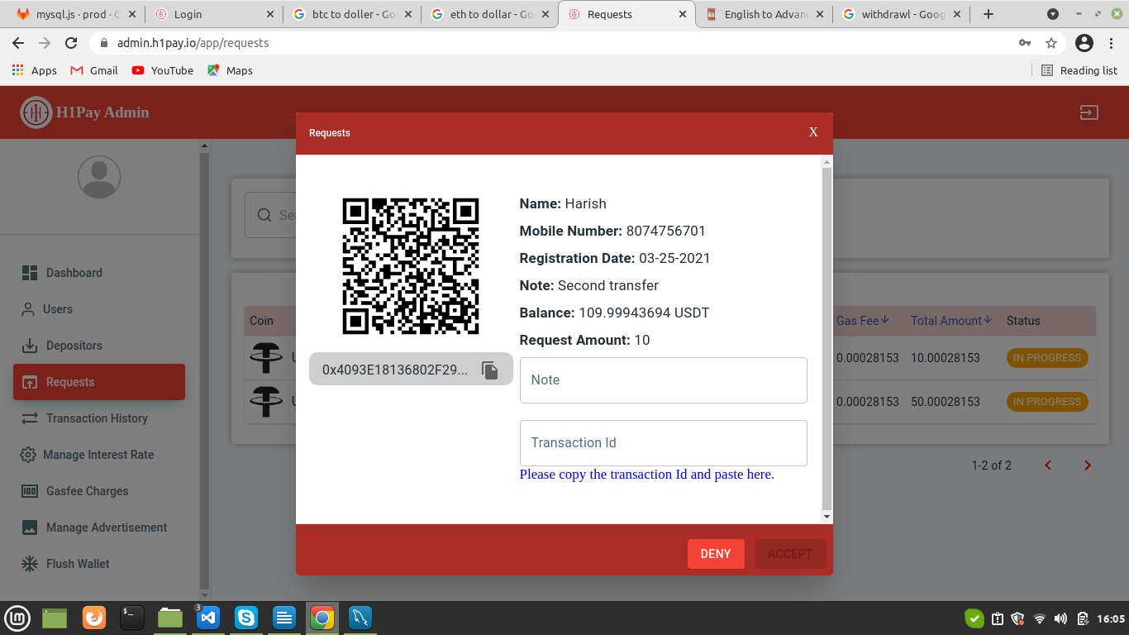

When the admin clicks the request thrown by a user, it displays the above page where the admin has to paste the transaction id and mention note accordingly to the transaction to accept it.

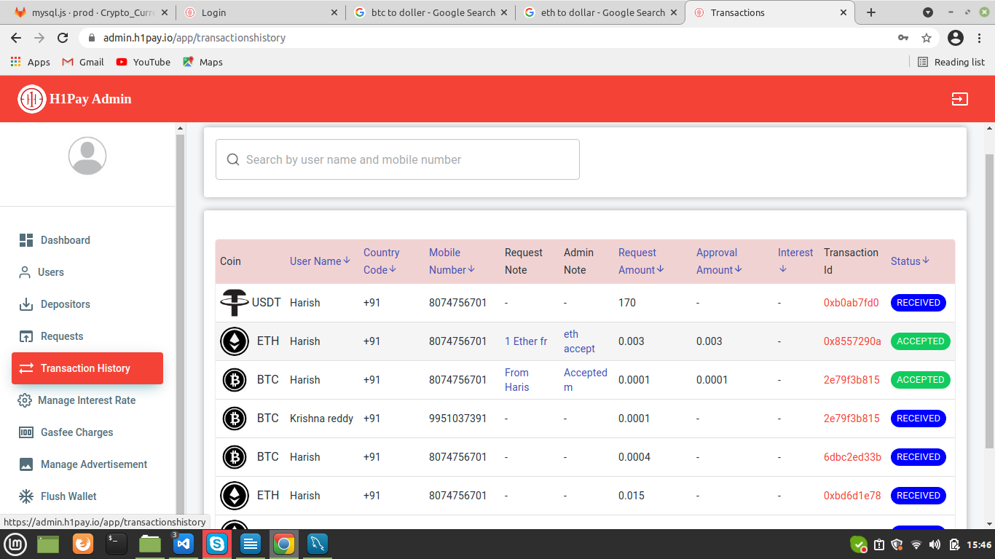

By clicking on Transaction History, it displays all the transaction details like Status, Amount, Note and Coin type of all the users.

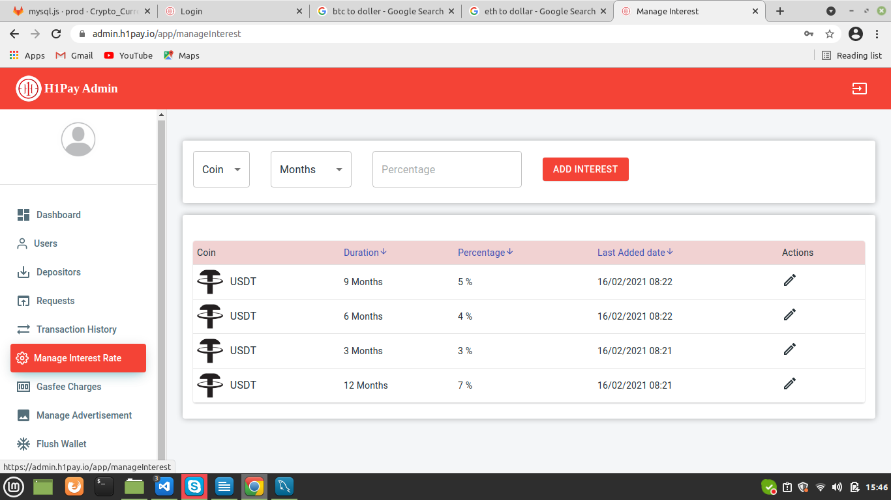

By clicking on Manage Interest Rate, it displays the fixed deposit percentage list according to duration. Also, we can add or update the Interest Rates.

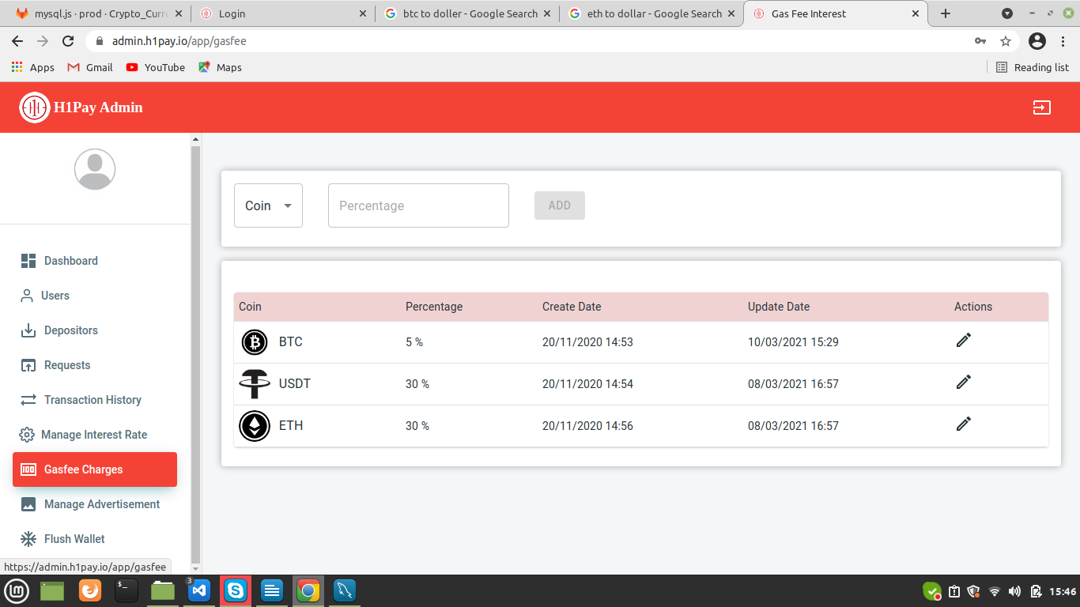

By Clicking on Gasfee Charges, it displays the amount of transaction fee deducts from the user account for a transaction based on the coin. Also admin can add or update the transaction fee.

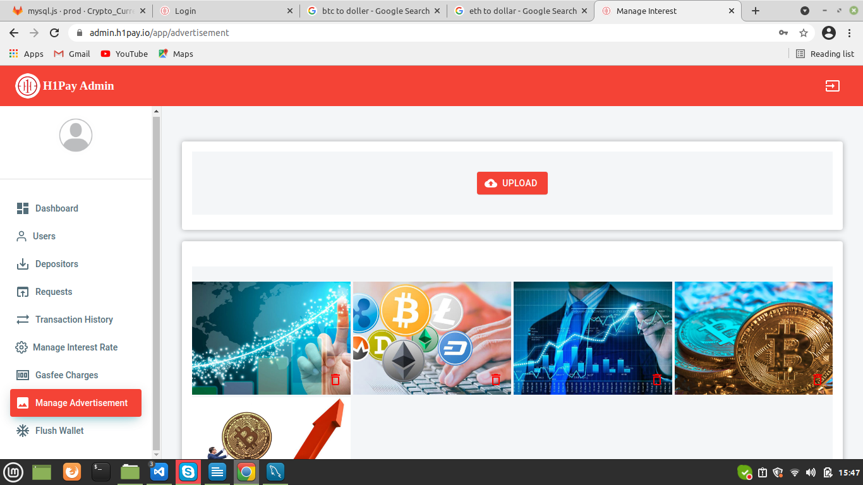

By clicking on Manage Advertisement, it displays the pictures that we added to advertise our application. We can add more pictures to advertise by clicking on the upload button.

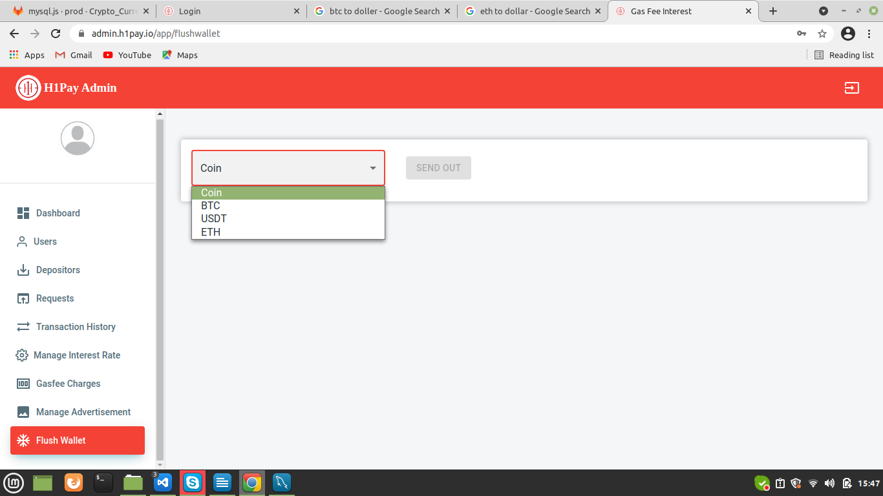

By clicking on Flush Wallet, the funds will transfer to the admin account from the User accounts.